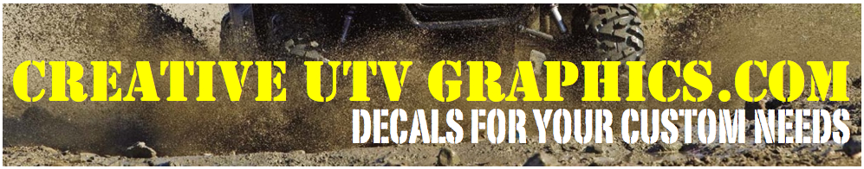
HONDA PIONEER CAMOWRAPS INSTALLATION RECOMMENDATIONS
The first step to any graphic application is cleaning the substrate. For a vehicle wrap, the day before film application, the car should be taken to a car wash that uses brushes. Manual cleaning is not recommended.
After the car is washed, thoroughly inspect the surface and edges for any remaining wax, polish, grease or grime. Any such substances must be removed using industrial cleaners or silicone detergents (isopropyl alcohol will not do the trick). CAUTION: Before using any solvent on a vehicle, be sure to test in an inconspicuous area to ensure the solvent won't damage the vehicle's paint. A final cleaning should be done with isopropyl alcohol to clean away any leftover impurities that could hinder the adhesive.
The next step is to remove any parts that may hamper the application (mirrors, trims, wiper blades, etc.). Check and clean the covered surfaces as described above. It is very important to allow the vehicle to dry completely. It can take up to 24 hours for a vehicle to dry fully, especially in humid or cold conditions, which may mean allowing the vehicle to dry indoors overnight before applying.

Recommended Installation Conditions:

Whenever possible, try to apply graphics indoors in a controlled environment, such as a covered car bay or garage. Doing so will not only help you control the temperature (ideally between 71 °F and 73°F), but also reduce the amount of wind, dust and other contaminants that may hinder the install process. Make sure your bay or garage is as clean as possible from dust or debris that may happen to circulate during your install (mop floor and dust with damp cloth prior to application) before bringing in the vehicle.

Necessary Tools:

· Low-tack masking tape-for positioning if laminate is not being used
· Felt-tipped squeegee-for applying the graphic
· Hobby knife (OLFA or XACTO knife)-for trimming away excess vinyl
· Air release tool-for removing air bubble
·Rivet brush-for installation over rivets
· Heat gun-for heating the vinyl on complicated applications

Application of the Film:

Very important: When performing a vehicle wrap you should start with the back of the vehicle first, then work your way to the front. This ensures that when you are driving the vehicle, the wind will not peel up the installed graphic.

Position the film to be applied and secure it to the car with small pieces of masking tape. Make sure that the film rises at least two inches past the edge of where the film is to be applied.
Lift the graphic from one side, slowly remove the backing paper from the film and stretch it equally over the part to be wrapped (For larger prints, you may only want to remove half of the release liner and lay the graphic up to it, then proceed with the rest of the graphic).
Apply the film with a felt tip squeegee, using short swipes that overlap the previous swipe. For rounded surfaces such as wings and tightly curved panels, work small sections at a time, using a heat gun to evenly heat the film. Cut and fold edges only after the film has cooled.
Trim the film on the car to ensure a proper fit. A printed piece of 60" film usually works best with transit applications (buses and panel trucks), whereas 48"-54" films typically work for passenger vehicle applications.
Trimming your graphic correctly is the most important part of the install, so pay extra attention to detail when performing this task. To avoid shrinking of the film or mechanical wear on the open cutting edge (through cleaning brushes, wind, etc.) make sure to not cut the film flush with car edges. Remove any elements, such as mirrors or wiper blades that would force you to make extra cuts or unnecessary marks in the vinyl.

Installation:

IMPORTANT: Any deep-drawn areas, borders and edges should be carefully reheated with a heat gun in order to quickly activate the adhesive. In case of deep corrugations, reheating the area to almost production temperature of the film (approximately 356°F) is recommended. While this temperature seems very high, it is necessary to achieve the required migration of softeners needed to harden the film in these areas of the car.
This temperature will not damage the adhesive substance or the vehicle's paint. Specialized shops offer infrared thermometers, which allow exact measuring of the underground temperature. Move heat gun constantly to avoid damage to the film.
When the wrapping is finished, if necessary, reheat all borders, edges and corrugations again with a heat gun. If you notice any tiny air bubbles under the film, don't panic-remaining tiny air bubbles under the film will diffuse through the film within a few days depending on the ambient temperature. Only larger bubbles should be slightly punctured by an air release tool and the air squeezed out with a squeegee.

Unpainted Plastic Parts

Be careful when applying the film to unpainted plastic parts of the car. If in doubt, use the water drop test. If the water continues to run off in drops after the cleaning procedure described above, it is not advisable to apply the film. If the water runs off without marked drop formation, the film can be applied to the plastic surface. In any case, such surface should also be completely smooth since no film will stick to a structured surface for long.

Once again thank you for choosing CreativeUTVgraphics for your custom needs!

